
PRESS RELEASE

Small element - Big protection

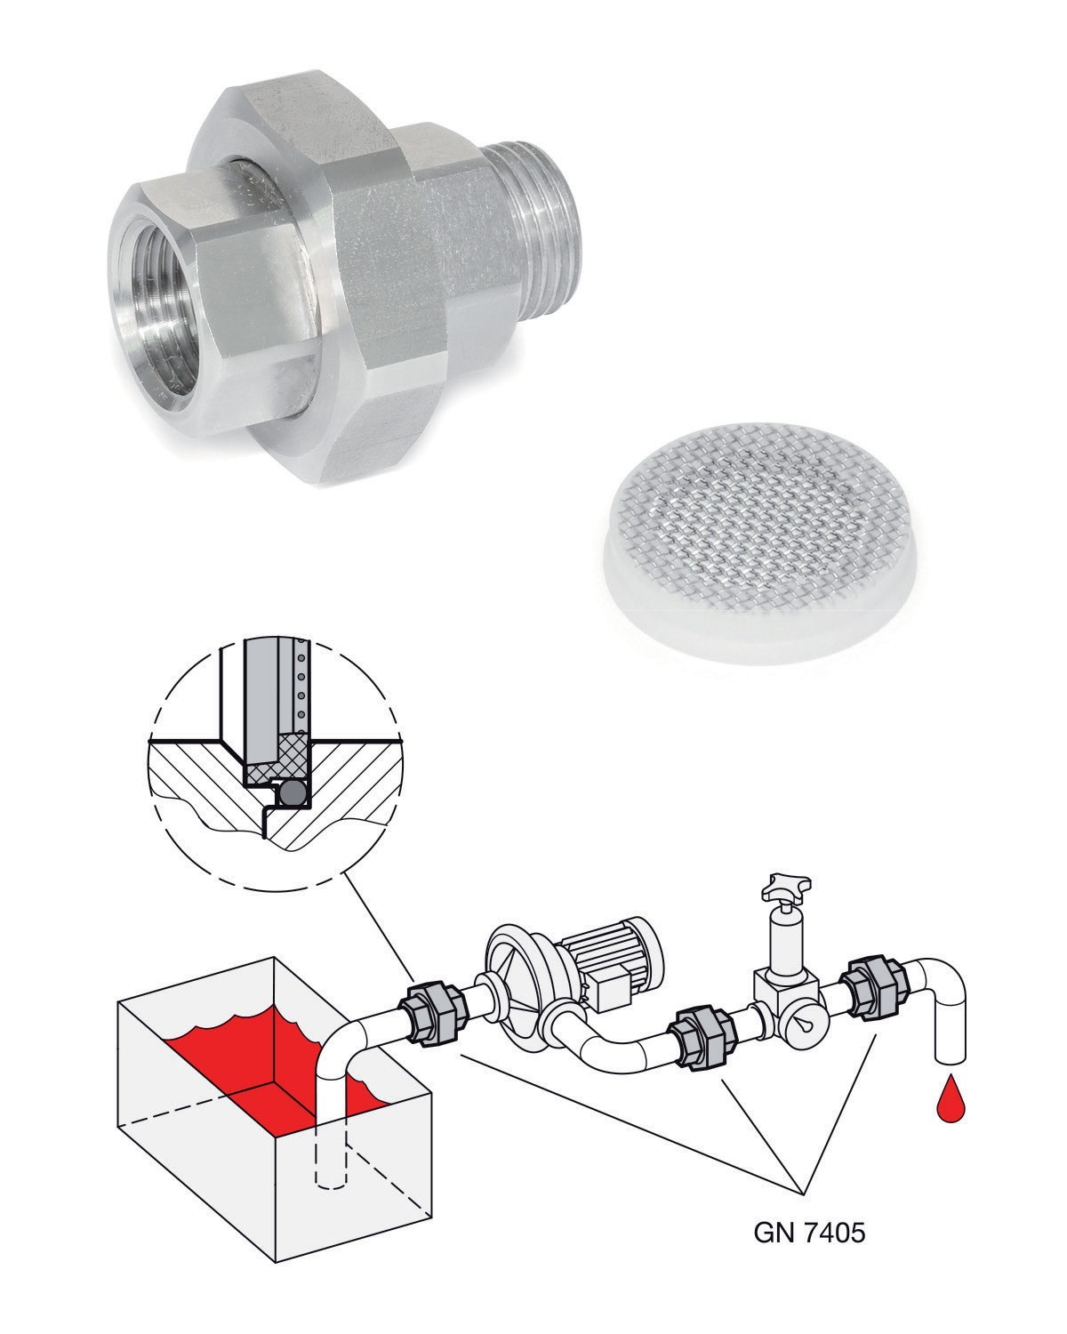
Strainer fittings protect key components in piping systems from damage.
Elesa+Ganter has now incorporated these important standard elements into its range of long-life stainless steel versions.

Even the smallest foreign bodies in piping systems can cause serious malfunctions, because they damage or destroy components such as pumps, valves, sliders or other technically complex units. It goes without saying that such incidents result in high costs due to downtime, repairs or replacements.

Simple, but effective, and above all long-lasting assistance is provided by the GN 7405 strainer fittings from Elesa+Ganter. Standard elements are simply installed into the piping system as upstream or downstream protective devices, the integrated stainless steel filters with mesh sizes of 100 µm or 500 µm stop
any foreign bodies from entering before these problems arise. Both parts of the strainer fittings housing are held together by a union nut and then sealed with an O-ring made of high grade NBR. Currently Elesa+Ganter offers its protective filters in three sizes with ⅜ , ½ and ¾ inch thread connectors, each in two versions: one with two- sided female thread and one with a combination of female and male threads, which are especially suitable for retrofits.



PRESS BOX

Elesa and Ganter India Pvt. Ltd.
A-54, Sector - 83,
Noida 201 305 (U.P.)
INDIA

Tel. +91 120 472 6666
Fax +91 120 472 6600

info@elesaganter-india.com
marketing@elesaganter-india.com

www.elesa-ganter.in
www.elesa-ganter.com

The union nut principle makes installation easier and facilitates cleaning or replacement of the integrated filter for maintenance. The stainless steel filter insert for GN 7403.1 can be purchased separately – either as a spare part or for fitting in installation spaces produced specifically according to diagrams. The filter surround made of fiber-reinforced polyamide creates a tight transition to
the O-ring and therefore to the installation location. As well as this, the filters are ideal for a wide range of media, including gas. Elesa+Ganter states flow rates for water and HPL 46 hydraulic oil.

GN 7405 strainer fittings can be fitted with special connector threads, for example, allowing them to be customized, just like the majority of standard elements from Elesa+Ganter.

Find out more at www.elesa-ganter.in

